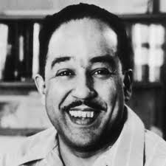
Dreams

Langston Hughes, 1902 - 1967
Hold fast to dreams
For if dreams die
Life is a broken-winged bird
That cannot fly.

Hold fast to dreams
For when dreams go
Life is a barren field
Frozen with snow.

#2 Harlem (Dream Deferred)
Published: 1951
Poem:-
What happens to a dream deferred?

Does it dry up
like a raisin in the sun?
Or fester like a sore—
And then run?
Does it stink like rotten meat?
Or crust and sugar over—
like a syrupy sweet?

Maybe it just sags
like a heavy load.

Or does it explode?

I, Too

Langston Hughes, 1902 - 1967
I, too, sing America. I am the darker brother. They send me to eat in the kitchen When company comes, But I laugh, And eat well, And grow strong. Tomorrow, I’ll be at the table When company comes. Nobody’ll dare Say to me, “Eat in the kitchen," Then. Besides, They’ll see how beautiful I am And be ashamed— I, too, am America.

----------------------------

I Hear America Singing

Walt Whitman, 1819 - 1892
I hear America singing, the varied carols I hear,
Those of mechanics, each one singing his as it should be blithe and strong,
The carpenter singing his as he measures his plank or beam,
The mason singing his as he makes ready for work, or leaves off work,
The boatman singing what belongs to him in his boat, the deckhand singing on the steamboat deck,
The shoemaker singing as he sits on his bench, the hatter singing as he stands, The wood-cutter’s song, the ploughboy’s on his way in the morning, or at noon intermission or at sundown,
The delicious singing of the mother, or of the young wife at work, or of the girl sewing or washing,
Each singing what belongs to him or her and to none else, The day what belongs to the day—at night the party of young fellows, robust, friendly,
Singing with open mouths their strong melodious songs.

