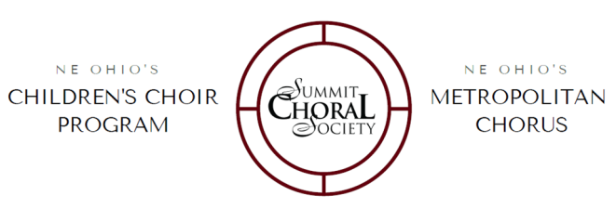

50 S. Main Street, LL #130

Akron . OH . 44308

summitchoralsociety.org 330●434●SING(7464)

**BOARD OF DIRECTORS**

**Christopher Burnham,** *President*

Development Finance Authority of Summit County

**Brian Moore**, *Vice President*

Roetzel & Andress

**Linda Hetson,** *Treasurer*

Akron Children’s Hospital

**Patricia Biddle,** *Secretary*

Bridgestone America, Inc. (Retired)

**Benjamin Comston**

Genesis Financial Services

**Kelli Fetter**

Downtown Akron Partnership

**Julie Firestone**

Brouse McDowell

**Hannah Flesch**

Ameriprise Financial Services, Inc.

**Andrew Gordon-Seifert**

Vorys, Sater, Seymour & Pease LLP

**Jason Lorenzon**

Lorenzon Law LLC

**Francis Mencl**

Emergency Physician

Professor of Emergency Medicine NEOMED

**Gary E. Mosteller**

Integrity Print Solutions, Inc

**Melissa A. Orenich**

Skoda Minotti

**Drew C. Reilly**

Judicial Attorney at the Akron Municipal Court

**Matthew Stein**

Medical Mutual of Ohio

**Joseph Storsin, Jr.**

FirstEnergy

**Charles Uray, Jr. P.E., P.S.**

Engineer & Land Surveyor, Retired

**Suganthi Alagarsamy Veerappan, MD, MPH**

Summa Senior Care Services

**EXECUTIVE & ARTISTIC STAFF**

**Shara Cocchiola**

Executive & Artistic Director

**Heather Cooper**

Principal Conductor

**Emily Garlock**

Director of Musical Operations, Choir Director

**Rachel Jervis**

Director of Marketing & Event Management

**Diane Kilo**

Grantsman & Bookkeeper

**Melanie Mesmer**

Choir Director, Musicianship Instructor

**Alexander Looney**

Choir Director, Musicianship Instructor

**Jessica Bell**

Choir Director, Musicianship Instructor

**Steven Cocchiola**

Musicianship Instructor & Accompanist

**Beth LeHoty**

Pianist

**Beverly Kalasky**

Pianist

June 1, 2018

Dear Friend of Summit Choral Society,

Summit Choral Society (SCS), Akron’s premier choral arts organization serving the Greater Akron area since 1990, invites you to support us through the enclosed sponsorship opportunities. These exciting packages have been designed specifically to help you promote your business and brand recognition through built in advertising offers to the thousands of singers and patrons involved with SCS this season! Additionally, your sponsorship not only helps to underwrite the cost of these programs, but also supports Akron’s premier choral music education and performance organization that serving children and adults in the greater Akron community.

Included in this mailing you will find the **Season Sponsor/Donor Benefit Package** the **Season’s Events Calendar as well as the Sponsorship Remittance Card.** The ***29th PRIME*** season includes performance events throughout Akron: the historic St. Bernard Catholic Church, Greystone Hall, the Akron Art Museum, The Auditorium at Cuyahoga Falls, the John S. Knight Center, Akron Centre Plaza, as well as nationally on tour at The Grand Ole Opry Pre-Show and Smoky Mountain Music Festival, TN.

SCS thanks you in advance for your sponsorship this season!

Please fill out the Sponsorship Remittance Card enclosed by

August 1, 2018 to: **Summit Choral Society   
 50 South Main Street, LL #130**

**Akron, OH 44308.**

If you have any questions or need additional information, please feel free to contact Summit Choral Society. Thank you for supporting the quality programs offered by SCS and for helping us in our endeavor to provide excellence in choral education and performances throughout Akron!

With sincere thanks,

Shara L. Cocchiola

Executive & Artistic Director

[scocchiola@summitchoralsociety.org](mailto:scocchiola@summitchoralsociety.org).